**CE376 Programming in Python UT-2**

[18DCE115 Kashyap Shah]

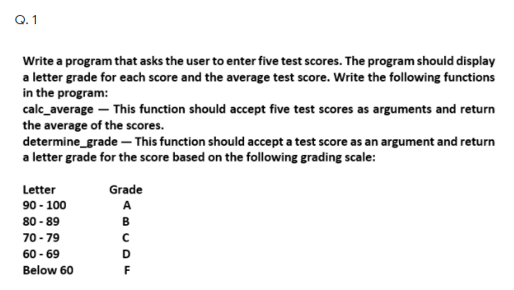

**PROGRAM CODE:**

#Taking Values

def main():

scores = input("Enter five test scores separated by commas: ")

return [int(num) for num in scores.split(",")]

#function to check grade

def determine_grade(num):

if 90 <= num <= 100:

letter_grade = "A"

elif 80 <= num <= 89:

letter_grade = "B"

elif 70 <= num <= 79:

letter_grade = "C"

elif 60 <= num <= 69:

letter_grade = "D"

else:

letter_grade = "F"

return letter_grade

def calc_average(grades):

average = sum(grades) / len(grades)

grade = determine_grade(average)

print("The average is: {:.1f} which is {}".format(average, grade))

print("Prepared By: Kashyap Shah (18DCE115)")

#function to print grade

def show_letters(num, letter_grade):

print("{:.1f} is {}\n".format(num, letter_grade))

lst = main()

for n in lst:

show_letters(n, determine_grade(n))

calc_average(lst)

**OUTPUT:**

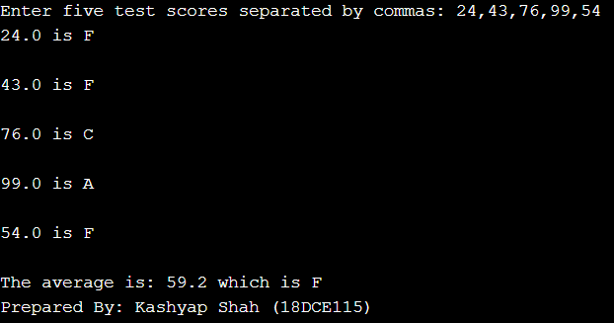

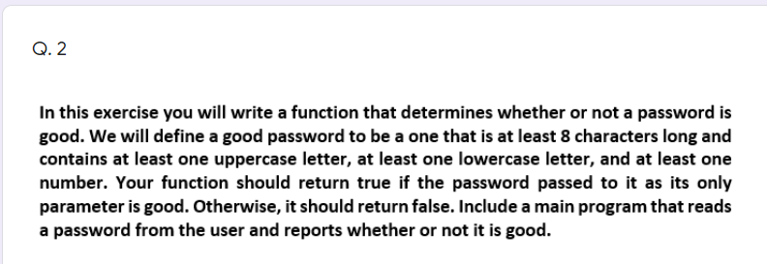

**PROGRAM CODE:**

# Function to validate the password

def password_check(passwd):

SpecialSym =['$', '@', '#', '%']

val = True

if len(passwd) < 6:

print('length should be at least 6')

val = False

if len(passwd) > 20:

print('length should be not be greater than 8')

val = False

if not any(char.isdigit() for char in passwd):

print('Password should have at least one numeral')

val = False

if not any(char.isupper() for char in passwd):

print('Password should have at least one uppercase letter')

val = False

if not any(char.islower() for char in passwd):

print('Password should have at least one lowercase letter')

val = False

if not any(char in SpecialSym for char in passwd):

print('Password should have at least one of the symbols $@#')

val = False

if val:

return val

# Main method

def main():

passwd = input("Enter your value: ")

if (password_check(passwd)):

print("Password is valid")

else:

print("Invalid Password !!")

# Driver Code

if __name__ == '__main__':

main()

**OUTPUT:**

